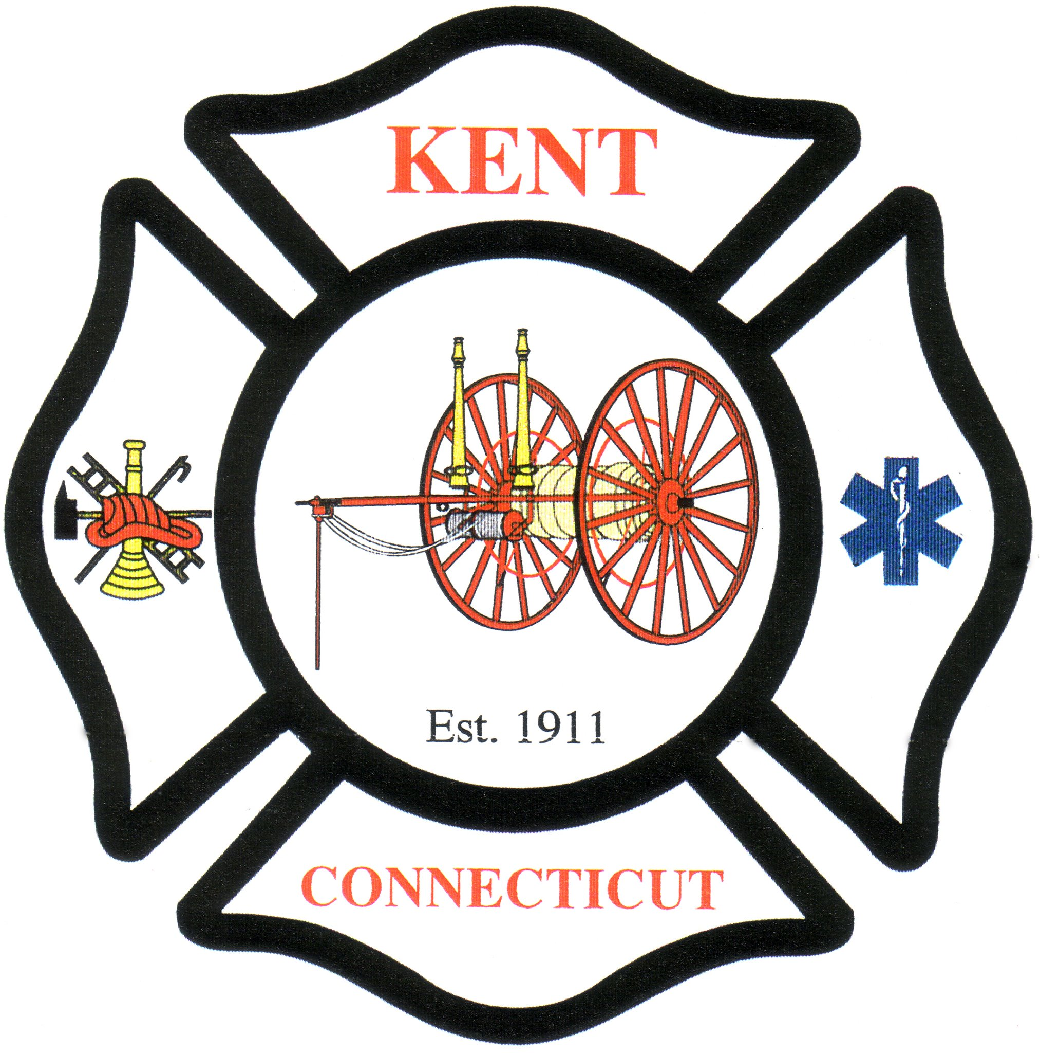

Kent Volunteer Fire Department, Inc

28 Maple St

Kent, CT 06757

EMS Staffing Committee Meeting

Thursday, April 21, 2022

8:00 pm

Kent Volunteer Fire Department

28 Maple St.

Kent, CT

**Meeting Minutes:**

Attendees: Bonnie Donzella, Alex Limbos, Mary Ann VanValkenburg.

Call to order 8:03 pm

Public/Member Comment: None

Review committee charge:

*Complete a comprehensive review of the Kent Volunteer Fire Department staffing model, research best practice options moving forward for (EMS and fire) staffing, and present an action plan to the Department for possible adoption. If and when a proposal is adopted by the Department, the committee is tasked to complete implementation of the action plan.*

Old Business:

* Discussion on Joyce’s email re: Cirma
* KVFD does have an EIN#

Bonnie to reach out to Matt for notes on sleeping quarters for paid staff.

Alex to look into statutory requirements for sleeping quarters.

Mary Ann will contact Jeff @ VFIS to ask about coverage for paid employee?

Next meeting is scheduled for Thurs., May 12, @8:00 pm

Meeting adjourned @ 9:04 pm

Respectfully submitted,

Bonnie Donzella